**Practical 5**

**Aim: HIVE Installation**

**Start the hadoop and verify all services are started**

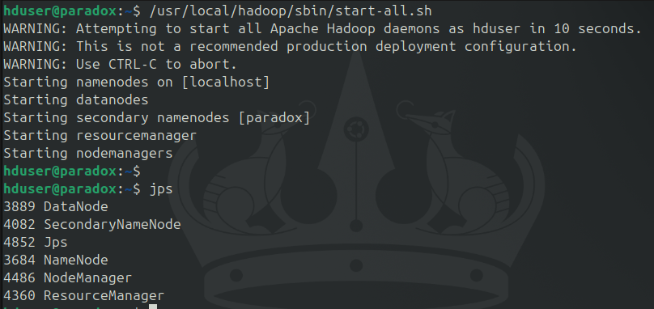/usr/local/hadoop/sbin/start-all.sh

**Navigate to /usr/local/**

sudo tar xvzf /home/hduser/Downloads/apache-hive-3.1.2-bin.tar.gz

sudo mv apache-hive-3.1.2-bin/ hive

sudo chmod 777 hive

**Add the HIVE_HOME path in the bashrc file.**

sudo nano ~/.bashrc

#add following lines

export HIVE_HOME=/usr/local/hive

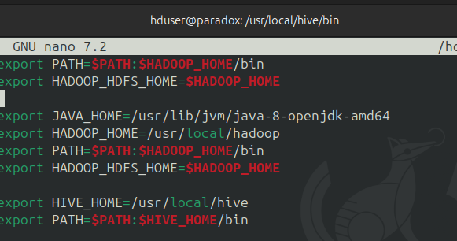export PATH=$PATH:$HIVE_HOME/bin

source ~/.bashrc

**Change the directory to /usr/local/hive/bin**

**and add the following lines in hive-config.sh**

cd /usr/local/hive/bin

sudo nano hive-config.sh

export HADOOP_HOME=/usr/local/hadoop

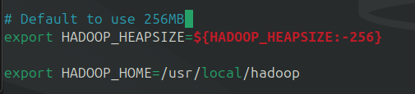

**Hive is installed now, but we need to first create some directories in HDFS for Hive to store its data**

hdfs dfs -mkdir /tmp

hdfs dfs -chmod g+w /tmp

hdfs dfs -chmod o+w /tmp

hdfs dfs -mkdir -p /user/hive/warehouse

hdfs dfs -chmod g+w /user/hive/warehouse

hdfs dfs -chmod 777 /tmp

hdfs dfs -chown -R hduser:supergroup /user/hive/warehouse

hdfs dfs -chmod -R 777 /user/hive/warehouse

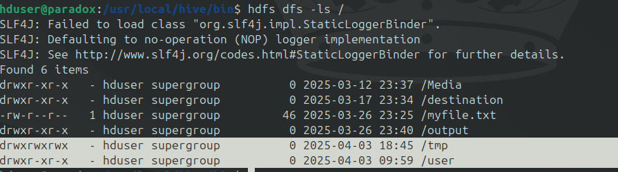hdfs dfs -ls /

**Initialze the database schema**

cd /$HIVE_HOME/bin

sudo ./schematool -initSchema -dbType derby

There is compatibility error between Hadoop and Hive guava versions.

To fix the NoSuchMethodError, Locate the guava jar file in the Hive lib directory

Remove the guava jar file from /hive/lib

sudo rm lib/guava-19.0.jar

# Copy the guava jar from hadoop lib to hive lib directory

sudo cp $HADOOP_HOME/share/hadoop/common/lib/guava-27.0-jre.jar /usr/local/hive/lib/

# Once copied, Use the schematool command once again to initiate the Derby database.

cd /$HIVE_HOME/bin

sudo ./schematool -initSchema -dbType derby

# Note for Error: FUNCTION 'NUCLEUS_ASCII' -

sudo rm -rf metastore_db  
Start HIVE:

cd /usr/local/hive/bin

sudo ./hive

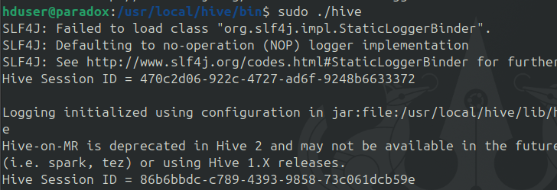

**Create a database and show**

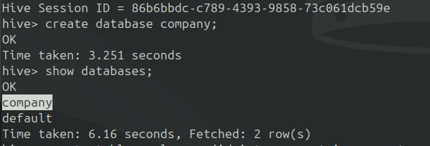create database company

**Create Employee table**

create table employees (id int, name string, country string, department string, salary int) row format delimited fields terminated by ' ';

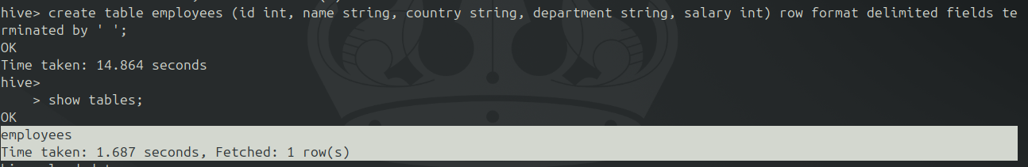

**Load the data into a table from a file**

sudo nano employees.txt

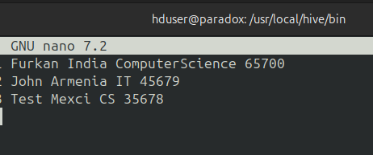Enter few rows without spaces

load data local inpath "./employees.txt" into table employees;

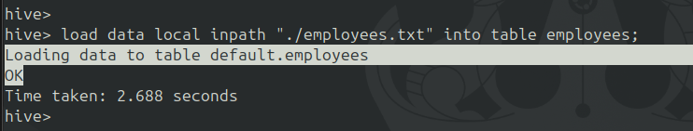**Reading the Table Data**

select * from employees;

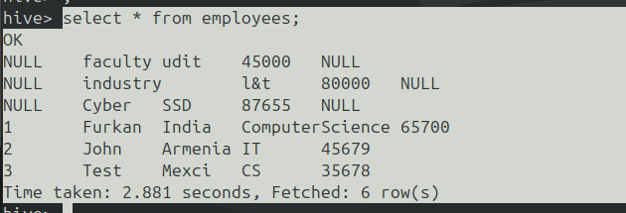

**Conclusion:** The Practical to install, configure and execute hive is successfully executed.